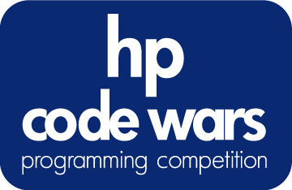

March Madness
Problem #14 | Advanced | 18 Points

C programmers: your program name must be: prob14.exe
JAVA programmers: your program name must be Prob14.class
Task (problem) Description:
The NCAA hoops tournament is just around the corner, and soon, everyone will be filling out their brackets. Before you make your predictions, you decide a little research is in order. As part of your research, you would like to look at last year's tournament to see how various teams fared. Unfortunately, the only data you can find is a simple listing of the scores for each game of the tournament. Even worse, they are in random order!

To make it easier on yourself, you decide to write a program that will read in all the scores, then print out an easy to read report that lists each game and score by round. While there are always 64 teams in the NCAA tournament (excluding the "play-in" game loser), your programs should work for any 2^{n} (n>0) number of teams.

Consider the following bracket as you look at the example.

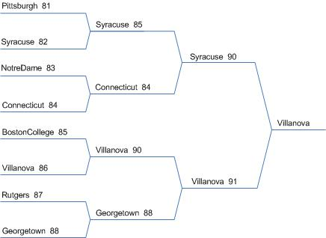

Program Input:
The input file (c:\codewars\prob14.in) consists of the results of each game of the tournament. Each game will be shown as two lines of input. The first line begins with the team listed on the top line of the bracket followed by a space and their score. The second line contains the bottom team. A blank line separates all the games. Team names will not contain any spaces and be no longer than 25 characters.

Syracuse 85
Connecticut 84

Pittsburgh 81
Syracuse 82

Rutgers 87
Georgetown 88

BostonCollege 85
Villanova 86

Syracuse 90
Villanova 91

NotreDame 83
Connecticut 84

Villanova 90
Georgetown 88

Program Output:
You will output a report to a file (prob14.out). Your report will first show the winner of the tournament. Then, beginning with the last round and working toward the first, print out the round number followed by the results of each game in that round. Each game should be listed in the order (top to bottom) they would appear on a tournament bracket. You must follow the same punctuation and spacing as in the output below.

Winner:
Villanova

Round 3:
Syracuse 90
Villanova 91

Round 2:
Syracuse 85
Connecticut 84

Villanova 90
Georgetown 88

Round 1:
Pittsburgh 81
Syracuse 82

NotreDame 83
Connecticut 84

BostonCollege 85
Villanova 86

Rutgers 87
Georgetown 88

